14.87: a) The speed of the liquid as a function of the distance y that it has fallen is 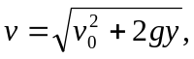 and the cross-section area of the flow is inversely proportional to this speed. The radius is then inversely proportional to the square root of the speed, and if the radius of the pipe is 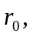the radius r of the stream a distance y below the pipe is

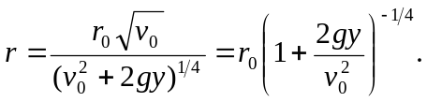

b) From the result of part (a), the height is found from 